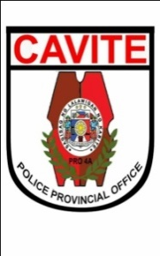Republic of the Philippines

NATIONAL POLICE COMMISSION

**PHILIPPINE NATIONAL POLICE, POLICE REGIONAL OFFICE CALABARZON  
CAVITE POLICE PROVINCIAL OFFICE**

**CARMONA MUNICIPAL POLICE STATION**

J.M. Loyola St., Brgy.Maduya, Carmona, Cavite

**MEMORANDUM**

FOR : Acting Provincial Director

(ATTN: C, PIDMB/S7)

FROM : Acting Chief of Police

SUBJECT :  **Submission of Actual Number of PUPCs and Total Number of   
 Days under PNP Custody**

DATE : December 01, 2021

1. References:
   1. Memorandum from the Regional Director with subject Guidelines for the Grant of Payment of Subsistence Allowance for Persons Under PNP Custody (PUPCs)dated August 16, 2020; and
   2. Fiscal Directive Nr 2019-17 "AMENDMENT OF THE GUIDELINES IN THE PAYMENT OF SUBSISTENCE ALLOWANCE FOR PERSONS UNDER PNP CUSTODY (FORMERLY SUBSISTENCE ALLOWANCE FOR DETAINEES)"
2. This office would like to request for issuance of Subsistence Allowance(SA) of Persons Under Police Custody (PUPCs) of this station for the month of November 2021.
3. In this regard, attached is the list of PUPCs together with its recapitulation following the prescribed format.
4. Request approval of para 2.

**JOSEPH C CARLIT**

Police Major